CNIT 38000: Assignment #6

Activity Diagram (AD)

## Using your corrected Context Model Diagram (CMD) from Assignment #1, your corrected Requirements (REQ) from Assignment #2, and your corrected Event Analysis Matrix (EAM) from Assignment #3 and Use Case Diagram (UCD) from Assignment #4, and Use Case Narratives (UCN) from Assignment #5, and the following additional SecureIT banking system information, prepare:

## An Activity Diagram (AD) based on your use case narrative above. Your activity diagram should have four (4) partitions (swimlanes). Show both typical and alternative courses of action.

LAB OBJECTIVES

* Model an Activity Diagram (AD).
* Classify Symbols on an Activity Diagram.
  + Apply Initial Node Symbol - Portrays the beginning of a set of actions or activities



* + Apply Activity Symbol – Is used to represent a set of actions to be grouped together.

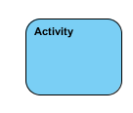

* + Apply Action Symbol – A task to be performed

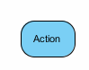

* + Apply Control Flow Symbol – Shows the sequence of execution.



* + Apply Object Flow Symbol - Show the flow of an object from one activity (or action) to another activity (or action).



* + Apply Decision Symbol - Represent a test condition to ensure that the control flow or object flow only goes down one path

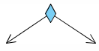

* + Apply Merge Symbol - Bring back together different decision paths that were created using a decision-node.

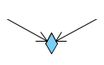

* + Apply Fork Symbol - Split behavior into a set of parallel or concurrent flows of activities (or actions)

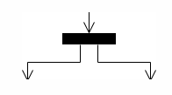

* + Apply Join Symbol - Bring back together a set of parallel or concurrent flows of activities (or actions).

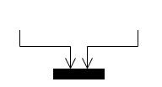

* + Apply a Final Node Symbol - Stop all control flows and object flows in an activity (or action)



* + Apply Swimlane and Partition Symbol - A way to group activities performed by the same actor on an activity diagram or to group activities in a single thread

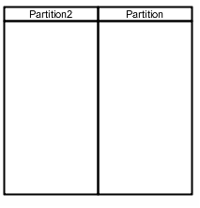

**System Narrative**

Additional Banking System information:

The potential customer applies for a bank account by submitting a completed application to the bank manager. The bank manager reviews the application for any errors or omissions, and if there are any, requests that the potential customer resolve them and then resubmit the application. After the manager verifies the application doesn’t contain any errors or omissions, they log on the system (if they are not logged in already), they use the system to select the option to open a new account (manager should have been previously logged on the system). The system responds by prompting the user for the new account information (name, address, DOB, phone number, SSN, etc.). The manager provides this information (reads it off the application) to the system and the system verifies it in terms of data and format checking. If there are problems, the system prompts the user to correct.

Once correct, the system submits a request to the credit bureau for a credit report which includes the credit score. The credit bureau responds with the credit report and the system displays the credit report information to the user and then prompts them to approve or deny the application. The manager will review the credit report to ensure credit worthiness and, if worthy, approves the account. The system responds by generating: 1) an account number; 2) storing the account information; and 3) generating an account identification card which is given to the customer (Items 2 and 3 are performed at the same time). If the manager decides not to approve the account, he notifies the potential customer that they have been denied. The system stores the application as rejected and then generates a letter stating the reasons the application was rejected, and then the letter is sent to the potential customer.

**REQUIREMENTS:**

1. You **MUST** draw your diagram using Microsoft Visio Professional or Visual Paradigm Community Edition. The templates that your Activity Diagram and UML are to be used.
2. If you are using MS Visio Professional, for document type, use **ACTIVITY DIAGRAM.** Otherwise, use the UML Templates for Visual Paradigm.

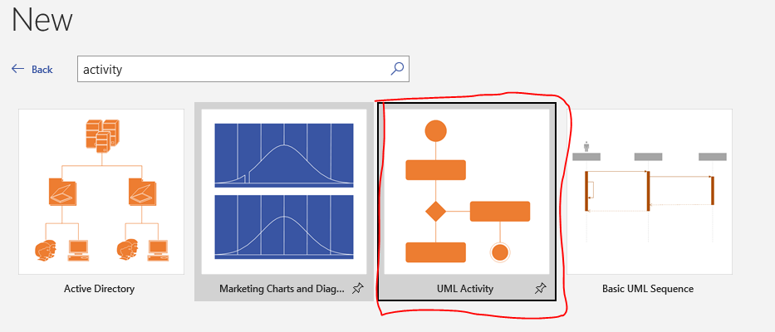

1. For the shapes, use the UML Activity toolbar.

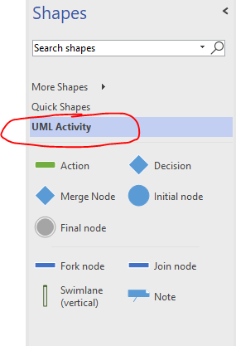

1. Use a TITLE BLOCK shape to document ALL your assumptions.
2. Time is **NOT** an actor on an Activity Diagram, but System is.
3. Copy and paste your diagram into the Word document (Assignment #6 - Student Answers.doc) where indicated, replacing the three (3) lines of yellow, highlighted text. Add your name to the document header, replacing the yellow, highlighted text. NO .PNG files.
4. DO NOT zip your file
5. Attach the .VSDX or VPP file in case I have questions.
6. DO NOT use an old student’s file, as there are some changed system, actor, process names, etc. in this semester’s assignments.